Source URL : <http://www.englisch-hilfen.de/en/words/charts.htm>

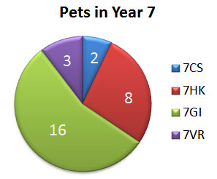

1 Introduction

Here you say what the diagram is about. Mind the title of it and do not forget to include the source.

The pie chart is about the pets in Year 7. The chart is divided into 5 parts. It is taken from

2 Message of the diagram

The largest number of pets are in form 7GI. There are 16 pets.  
The second largest number of pets are in form 7HK. There are 8 pets.  
So there are more than twice as many pets in form 7GI.   
The chart shows that there are only 2 pets in form 7CS and 3 in form 7VR.

3 Conclusion

So we can say that the most pets of Year 7 are in form 7GI and the least in form 7CS. There are more than 50 per cent of all the pets in one form - form 7GI.

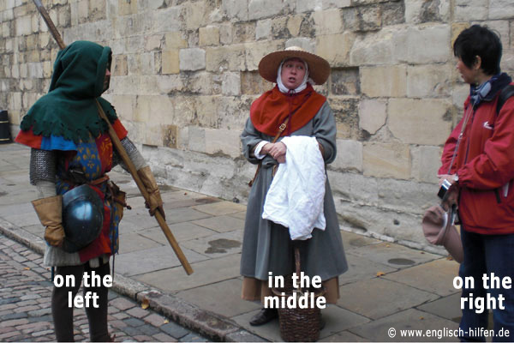

1. Introduction

* The photo/picture shows ...
* It was taken by/in ...
* It's a black-and-white/coloured photo.

2. What is where?

* In the foreground/background you can see ...
* In the foreground/background there is ...
* In the middle/centre there are ...
* At the top/At the bottom there is ...
* On the left/right there are ...
* Behind/In front of ... you can see ...
* Between ... there is ...

3. Who is doing what?

Here you describe the persons in the picture or you say what is happening just now. Use the [Present Progressive](http://www.englisch-hilfen.de/en/grammar/pres_pro.htm).

4. What I think about the picture

* It seems as if ...
* The lady seems to ...
* Maybe ...
* I think ...
* ... might be a symbol of ...
* The atmosphere is peaceful/depressing ...
* I (don't) like the picture because ...
* It makes me think of ...

http://www.essaybuilder.net/LineGraphs.html

Comparison Bar graph

– Why? Because x Axes show some country name which is not in **sequence** so we have to compare country to country.

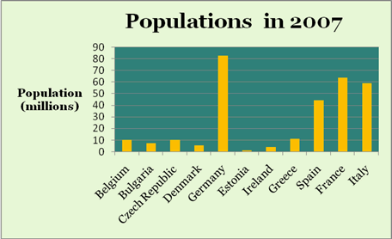

This chart shows the populations of some European countries in 2007. The country with the **largest** population is Germany, with over 80 million people **whereas** Estonia has the **smallest** population, at little more than a million. Belgium, Bulgaria, the Czech Republic, Denmark, Estonia and Ireland all have populations or ten million or less, while Greece has a population of about eleven million. **Apart from** Germany, the largest **countries** are Spain, France and Italy with populations **ranging from** about forty-four to sixty-three million. Together, the four largest countries account for over eighty per cent of the population of the countries shown.

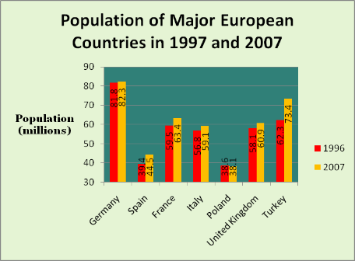

The graph shows the population major in European counties in 1997 and 2007. The Y axes shows the population in millions. It is clearly shows that, the country with largest population is Germany, with 81.8 m in 1997 and 82.3 in 2007, whereas Poland has smallest population in 1997 and 2007.

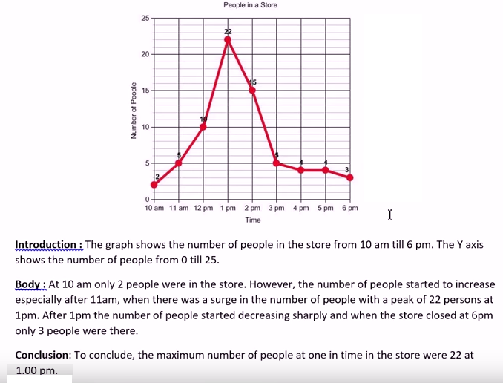

The line graph shows thefts per thousand vehicles in four European countries between 1990 and 1999.  Summarize the information by selecting and reporting the main features and make comparisons where relevant.

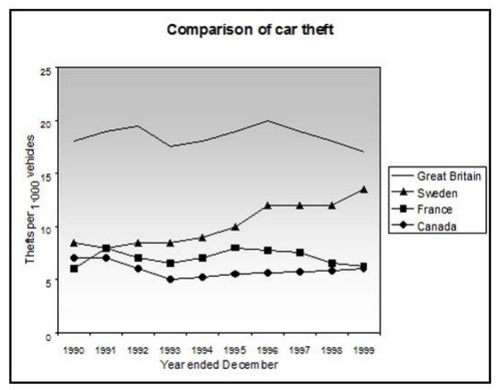

**The graph compared four different countries of Europe and the number of cars stolen per thousand between the years 1990 and 1999.** Great Britain showed the highest number of cases and fluctuated considerably over the decade, while the number of thefts in Sweden increased significantly, and France and Canada remained with the lowest figures barely/hardly changed during the period.

The figures for car theft/of stolen cars/of cars stolen/car theft figures varied greatly in Great Britain. Starting in 1990 with 18 per thousand cases, car theft peaked twice at 20 in 1992 and 1996, then dropped back to around to 17 in 1999. Compared to Great Britain over the same period, Sweden showed a significant rise in stolen vehicles, starting at 6 in 1990, and grew over the years to close to 13 in 1996. This number remained constant to 1998, then climbed to 14 in 1999.

France and Canada followed a very similar steady trend over the decade. France stood at 6 cases of stolen cars per thousand in 1990 and Canada was slightly higher at 7. Both declined slowly until 1993, when they began to rise slowly, each ending at 6 in 1999. However, France’s numbers surged between 1994 and 1997.

https://www.youtube.com/watch?v=sM5VgdjLYFI

Use five paragraph always for writing the essay:

1. Introduction consist of two sentences

Topic sentence (paraphrasing the topic)

Thesis sentence (agree/disagree/partially agree)

1. Body -1 (First main point)

* Agree
* Two sentences why agree

1. Body -2

* Supporting point 1, Number one (Firstly)
* Example
* Supporting point Number 2
* Supporting point Number 3
* Concluding the para (optional)

1. Personal opinion (only two sentence)
2. Conclusion

* 2 sentences
* Paraphrasing the introduction.

Format:

*Question*: Computer technology has had a more of a negative then a positive impact on society.

How far do you agree with this statement? Support your view with reasons and/or examples from your own experience.

1. The discussion on --------------- is debatable one and each side has its logical arguments. I believe that computer technology has more negative results on the society then positive.
2. On the one hand critics (positive impact) may point out that -------------------. They may argue that ---------------------------------------------------------.
3. However, in spite of these arguments, (negative impact) computer technology results in various unfavourable consequences.

* Firstly, ---------------------------------------------------------. For example, ----------------------.
* Secondly, ---------------------------------------------------------.
* Thirdly, ---------------------------------------------------------.

1. Lastly, in my opinion, in India the government is ---------------------------------------------------------.
2. To conclude, ---------------------------------------------------------, reason 1, reason 2, reason 3.

*Rough draft:*

|  |  |
| --- | --- |
| Agree | Disagree |
| Computer dependency | More time available |
| People losing jobs / Example: manufacturing | Example, mother child interaction (more) |
| Lazy, less energetic |  |
| More dependent |  |

The discussion on computer technology is a debatable one and each side has its logical arguments. I believe that computer technology has more negative results that positive results for the society.

On the one hand, critics may point out that one of the most significant benefit of computer technology is the availability of extra time. For example, mothers, unlike in the past now have more time to spend with their families, as less time is spent doing house chores, thanks to efficient computerised household machineries.

One the other hand, in spite of these arguments, computer dependency has negatively consequences for the community in various ways. Firstly, people are losing jobs because machines are increasingly taking over the roles of humans, such as in the car manufacturing sector. According to Times Magazine March 2014 edition, the proportion of Americans employed in manufacturing has dropped from 30 percent in the post- World War II years to around 10 percent today. Secondly, a large portion of the human population has lost enthusiasm because of technological dependency and is increasingly becoming lazier and less efficient.

Lastly, in my opinion, the government of India is taking a great initiative in educating its citizens against the negative impact of computer technology. Citizens are being encouraged to spend a significant portion of their time in physical activity like games and exercise, in order to compensate for their computer reliance and addiction.

To conclude, computer technology has more disadvantages than advantages and makes a society more dependent and less productive.

The Argument essay - states the writer's opinion at the beginning (thesis) and supports it with evidence.

Discussion Essay - analyzes the opinions of others and gives the writer's at the end.

|  |  |
| --- | --- |
| Discussion Essay – four paragraphs | Argumentative Essay |
| Introduction   * Background statement * Detailed background statement * The POV on the topic that will be analyze * Outline (the order will discuss these POV in) | Introduction   * Background statement * Detailed background statement * Thesis statement (what we are trying to prove) i.e *Dubai is the most expensive city in the planet* * Outline -> what Topic we speak about the SP1 & SP2 |
| First supporting paragraph   * It is believe by some * Example that supports POV 1 * Discussion statement – link the example to the POV 1 * Supportive statement those who agree with POV 1 ( As I understand some people are supporting) | First supporting paragraph (SP1)   * Topic subject that supports our thesis. * Example – must be true in real life. Evidence the topic that basically support the Topic 1 * Discussion – link the example to the topic * Conclusion – link the topic to the thesis. |
| Second supporting paragraph   * Statement of POV 2 * Example that supports POV 2 * Discussion statement – link the example to the POV 2 * Supportive statement those who agree with POV 2 ( we understand why some people supporting this POV 2) | Second supporting paragraph(SP2)   * Topic * Example * Discussion * Conclusion |
| Concluding paragraph   * summary of POV analyzed * statement of our POV * prediction or recommendations | Concluding paragraph – one or two sentences required   * Summary – retelling the two supporting topic briefly. * Restatement of the thesis - saying the thesis in different words * Predication or recommendation |
| *Where : POV = point of view* |  |

References:

1. <https://goo.gl/GXtkDp>
2. Free IELTS Ebook: <https://www.ieltspodcast.com/sign>  
   IELTS Essay Correction: [https://www.ieltspodcast.com/essay-co...](https://www.ieltspodcast.com/essay-correction/)  
   IELTS Online Course: [https://www.SentenceGuide.com](https://www.sentenceguide.com/)

Paraphrasing Technics:

1. Synonym
2. Verb transformation
3. Sentence restructure

1)

Nowadays = in modern time

Schools = Academic Institutions

Computer Game = Electronic activities and exercises

Lessons = Courses

Inside and outside the classroom = at school and at home

Education = academic development.

2)

This essay will outline the drawbacks and advantages employing electronic activities and exercises on academic development.

Solution will be examined to mitigate the harmful impact of electronic activities.

3)

In modern time, many academic institutions are employing electronic actives and exercises to instruct courses to children both at home and at school. This essay will outline the drawbacks and advantages of employing electronic activities and exercise on academic development. Solution will be examined to mitigate the harmful impact of electronic activities.

**In conclusion**, it is clear that pollution will continue to plague our planet for the foreseeable future. **However**, if individuals and governments act responsibly, there may come a day in the not too distant future when a more optimistic outlook is justified.

For the reference synonym:

* Good employer = fair employer or reasonable
* People = general public

**Types of images and graphs:**

|  |  |
| --- | --- |
| A Picture | Bar Graph |
| https://3.bp.blogspot.com/-sDp7AUqRPrQ/VrDXnVV5JhI/AAAAAAAAADE/SrTG_pDSlQc/s320/picture.jpg | https://1.bp.blogspot.com/-cPQ9vEOnHcQ/VrDXvZGbfVI/AAAAAAAAADM/jY5VzlxxtD8/s320/bargraph.jpg |
| Pie Chart | Line Graph |
| https://3.bp.blogspot.com/-QFp0zC3hGjE/VrDX2acBLxI/AAAAAAAAADU/fKnmYoypLEc/s320/pie%2Bchart.jpg | https://2.bp.blogspot.com/-TZej9DhTAkw/VrDX8l_LotI/AAAAAAAAADc/rLoJ8kHZtgI/s320/line%2Bgraph.jpg |
| A Map | A Table |
| https://4.bp.blogspot.com/-OuuBhErXT4c/VrDX_6Ndp-I/AAAAAAAAADk/EkBO6SEtz-E/s1600/map.jpg | https://4.bp.blogspot.com/-mlgrGO47zM8/VrDYDVKew2I/AAAAAAAAADs/4PS8Aab59zE/s320/table.jpg |
| Process Graph | Venn Diagram |
| https://4.bp.blogspot.com/-PquvqWZq3Ks/VrDYHNfimVI/AAAAAAAAAD0/w7_GizOT-f0/s320/process.jpg | https://2.bp.blogspot.com/-VkBxfJ3KXkM/VrDYKfg7uuI/AAAAAAAAAD8/vB2Xsusg2fs/s1600/venn.jpg |

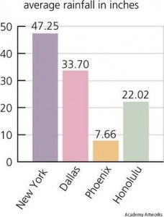

**Best Answer:** The given bar graph represents the average rainfall in inches for four cities in United States. If you follow the graph closely, you can observe that the majority rainfall occurs in New York, which closely touches to 50 percent, followed by Dallas, Honolulu and Phoenix with approximately 33, 22 and 7 percent. After analyzing the details given in this graph, we can conclude that, New York acquires majority rainfall and Phoenix held a last position.

Writing a conclusion:

1. In the end, ___________________
2. Nevertheless, ___________________
3. To sum up, ___________________
4. Overall ___________________
5. All in all ___________________
6. In the final analysis ___________________

Examples:

* It wasn’t funny, but all in all it was a good movie.
* To sum up, for a healthy hart you must take regular exercise and stop smoking.
* In the final analysis, profit is the motive.

Reorder Para

<http://www.pearson-pte.com/pte-academic-reading-material/re-order-paragraphs/>

<http://www.pearson-pte.com/pte-academic-speaking-material/describe-graphs/>

**Intro:**

The graph shows/depicts/illustrates/demonstrates…. The number of…. measured in percentage / millions ……from 19xx to 20yy.

*Note*: It is very important to say that you mention the first year and last year in the introduction.

**Overview:**

It is crystal clear that ______________

It can be clearly seen from the graph that ______________

It is explicitly shown that ______________

*Note*: Use “***trend***” words to describe the rest.

**Overview**: The chart shows the future trends in the percentage of American citizens over 65 years old.

**Point 1**: In 2010, about 13 percent of US citizens were over 65. This figure is predicted to rise steadily so that by 2035, it will be 20 percent.

**Point 2**: Between 2010 and 2030, the rise will be quite steady whereas between 2030 and 2035, the rise is less significant. – suggesting that the increase in the aging population may peak shortly after 2035.

**Conclusion**: However, the rise will have serious implications in areas such as the provision of government services.

If there is Pie Chart

Start with:

The pie chart compares….

***Example***: The pie chart compares the percentage of each favourite type of movie.

If there are about 4-5 parts or fewer in the pie chart, the second sentence should be

It is divided into 4 parts/slices: (mention the names of the parts)

It is divided into 5 parts: sci-fi, comedy, action, drama, and romance.

*depend on how fast you speak. If you can only speak slowly, ignore the part above.

If there are more than that: mention the extreme points straight away. Remember to use variations of structures:

Romance takes up to 30%...., which is the highest contribution in the chart.

5% of the pie chart belongs to…..

Comedy contributes the smallest proportion….

**Sample Answers: 1**

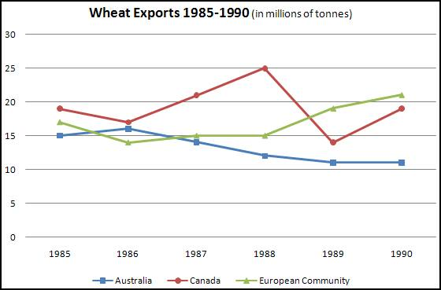

Describe Answer:

The Line graphs compares different countries in terms of amount of wheat they exported from the year 1985 to 1990. It is lucid that Canada exported approx 19 million tonnes of wheat in the year 1985 and reaches its zenith value 25 million tonnes in the year 1988. On the other hand Australia lags behind in exporting wheat ..Australia started with 15 million tonnes in 1985 and ended with 11 million tonnes in the year 2000

**Sample Answers: 2**

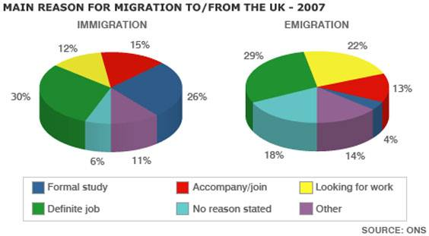

The pie chart illustrates the main reasons that people migrated and emigrated to the UK in 2007. We can clearly see from the pie chart that the definite job and searching for work accounted for the largest proportion of emigration and migration.  
To begin nearly one third of people went and left the UK for definite job, while one fifth of people emigrated for job search, only just over one in ten people immigrated for this purpose. Next just over a quarter of people immigrated to the UK for formal study, but this figure was only 4% for emigration.

**Eassy-1**

It is as important for school children to study music, art and sport as it is for them to become literate and numerate.' How far do you agree with this statement? Support your point of view with reasons and / or examples from your own experience.

In the modern world, primary education plays an important role with various subjects. It is important for academic institutions children to study music, art and sport to become scholarly. In this essay I will advocate both sides.

On the one hand side, the study of music, art and sport are good way to develop new skills along with education. It creates new opportunities for the children. Academic institutions has way to keep students healthy and physically fit. Furthermore, it’s a different kind of fun with education. For example, M.F. Hussain, he studied art in the academic institution and he started his career to landscape painting and he became world famous artist.

On the other hand side, the study of music, art and sport creates new opportunities in specific area which will really not helpful to survive in this society. Specific jobs are very limited and have less opportunities. Moreover, to become scholarly academic institutions must consider the vocational education such as computer awareness.

To sum up, academic institutions play important role to build the career path of children in their primary education. And it’s actually build the basic fundamental knowledge of children to build their interest in the subjects.

Re-tell lecture:

In every lecture have three important points, try to identify while listening.

1. What is the subject
2. What is the reason – Why he is talking about the subject
3. What is the conclusion he made.

<https://www.youtube.com/watch?v=QRC5eHpGVUg&list=PLRbgHqLCzjIcuzVdrVnORTY3rIEPNzc3S&index=2>

Introduction:

Can follow the below mention phrases:

The prof. gives the examples......

The prof. describe introduce species explain how

In the lecture the professor explains about the <<>>

The professor gives examples have tools, under the broad definition tools can included anything that is used without a